|  |  |
| --- | --- |
| ParkedCar | |
| Responsibilities | Collaborating Class |
| Know the car’s make, model, color, license number, and the number of minutes the car has been parked. | N/a |

|  |  |
| --- | --- |
| ParkingMeter | |
| Responsibilities | Collaborating Class |
| To know the number of minutes of parking time that has been purchased. | N/a |

|  |  |
| --- | --- |
| PoliceOfficer | |
| Responsibilities | Collaborating Class |
| To know the police officer’s name and badge number. | N/a |
| To examine a ParkedCar object and Parking Meter object and determine whether the car’s time has expired. | ParkedCar  ParkingMeter |
| To issue a parking ticket, or generate a ParkingTicket object, if the car’s time has expired. | ParkingTicket |

|  |  |
| --- | --- |
| ParkingTicket | |
| Responsibilities | Collaborating Class |
| To report the make, model, color, and license number of the illegally parked car. | ParkedCar |
| To report the amount of the fine, which is $25 for the first hour or part of an hour that the car is illegally parked, plus $10 for every additional hour or part of an hour that the car is illegally parked. | ParkingMeter  ParkedCar |
| To report the name and badge number of the police officer issuing the ticket. | PoliceOfficer |

|  |  |  |  |
| --- | --- | --- | --- |
| ParkedCar | ParkingMeter | PoliceOfficer | ParkingTicket |
| -make: String  -model: String  -color: String  -plate: String  -minutesParked: int | -minutesPurchased: int | -name: String  -badgeNumber: String | -car: ParkedCar  -officer: PoliceOfficer  -fine: Double |
| +ParkedCar()  +ParkedCar()  +getMake(): String  +getModel(): String  +getColor(): String  +getPlate(): String  +getMinutesParked(): int | +ParkingMeter()  +getMinutesPurchased(): int | +PoliceOfficer()  +PoliceOfficer()  +determineExpiration(): bool  +issueTicket(): ParkingTicket  +getName(): String  +getBadgeNumber(): String | +ParkingTicket()  +getFine() : double +getOfficerName() : String +getOfficerBadge() : String +getCarMake() : String +getCarModel() : String +getCarPlate() : String |

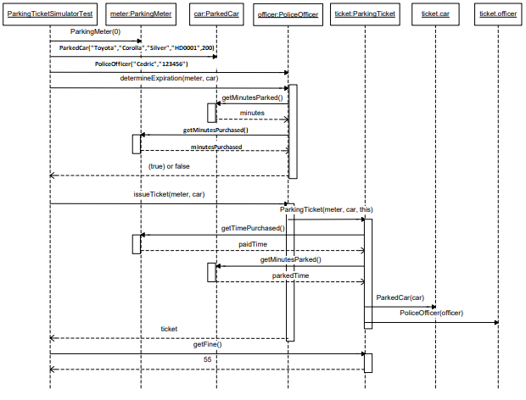

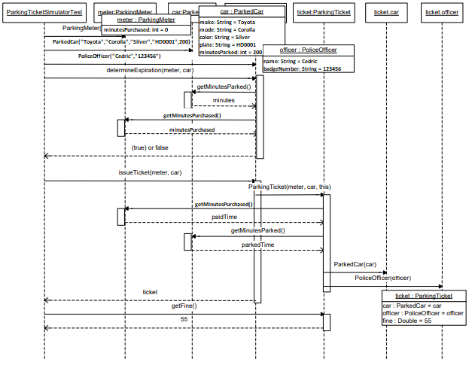

**2. Answer the following questions about the design process.**

a) Record all the design decisions made during the process of designing the system. You should include at what point in the design process you made the decision, what the decision was, and whether you had to make changes to the CRC model, class diagram model, sequence diagram, object diagrams, or code because of the decision.

|  |  |  |
| --- | --- | --- |
| **Point in process that the decision was made.** | **Decision.** | **Changes that were a result of the decision.** |
| Class diagram | Created two fields, ParkingMeter and ParkedCar, gave them private visibility. Accessor methods for the fields were created. | N/a |
| Class diagram | PoliceOfficer class determined expiration to achieve this I passed in references to ParkedCar and ParkingMeter objects. | N/a |
| Class diagram | ParkingTicket field will need to have references fields in PoliceOfficer and ParkedCar. ParkingMeter can be passed in as a value to the constructor. | N/a |
| Code | ParkingTicket requires that I at least pass in the ParkedCar object to its constructor as well as ParkingMeter or it won’t be able to create a ticket. | Changes to class diagrams. |
| Code | ParkedCar and PoliceOfficer must have copy constructors. | Changes to class diagrams. |
| Code | All objects need constructors that pass in values so all fields can be initialized. | Changes to class diagrams. |

b) Reflect on the design process and answer the following questions: When did you make the most changes in design decisions that affected previous decisions? Did you learn anything about design from these decisions that might make the next decisions easier?

The problem was extremely specific as to what parameters were needed so there wasn’t much room for creativity. I personally might have combined the meter and the ticket function since the parking meter doesn’t have much stand-alone function. I also did not understand the point of a copy constructor initially I thought it was as genuine waste of a space, so I did a bit of research and found they are useful for once you begin to have drastically larger code.